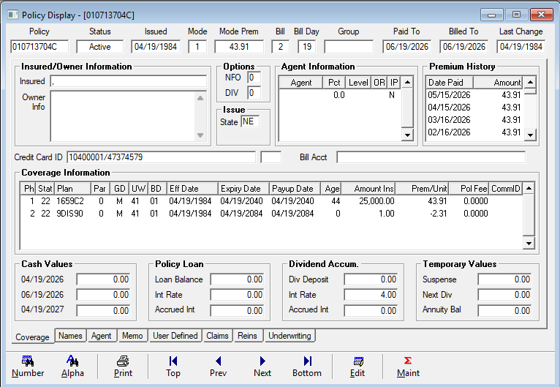
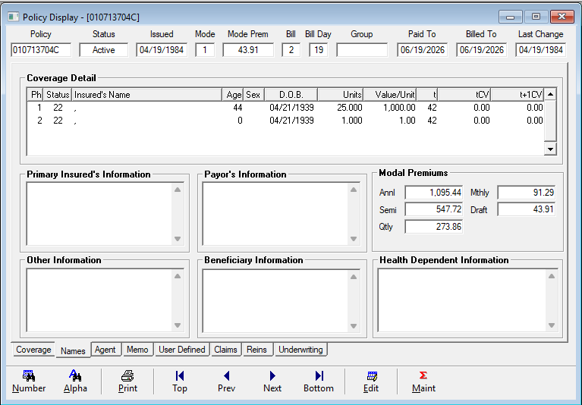

Issues:
- Bill Day 19 in QLAdmin, while LifePRO has Specified Bill Day/Code of 15 – Circled in Blue
  - PPOLC_PolicyMaster_Extract_20260530 Column AA (POLICY_BILL_DAY) lists 15
  - PPPAC_PACDetail_Extract_20260530 has PAC_DATE and BASE_DRAW_DATE (Columns D and E) of 20260615
- Last Change Date – 4/19/1984 vs 8/31/2009 – highlighted in yellow
  - The 8/31/2009 change date is listed in PPOLC_PolicyMaster_Extract_20260530 in Column K (LAST_CHNGE_DATE)
- Premium History stops at 1/15/2018, while LifePRO accounting history goes back to 1/7/2002
  - LifePRO has Post-Tefra Basis and Premiums Paid-to-Date – Yellow Highlight
    - Column BH (FV_Basis2) in PPBEN_PolicyBenefit_Extract_20260530 lists Basis
    - Question of how does QLAdmin capture the Total Premium paid and Cost Basis?
- Policy Owner, Insured, Beneficiary, and Payor all listed in LifePRO – Highlighted in Yellow
  - Names Listed on RelationshipNameAddressExtract_20260530 as well
    - Lines 7716 to 7722
- Underwriting Class is P on PPBEN_PolicyBenefit_Extract
- Routing Number is Missing Digit and QLAdmin is stating Credit Card ID vs Bank Acct
  - All ELEC_ABA_NUMBER on RelationshipNameAddress_Extract_20260530 are limited to 8 characters
    - It appears all are missing the last digit
      - See 010713704C LifePRO Enter PAC Screenshot (Circled in Red)
      - There appear to be 872 unique Bank Name_IDs
- Interest Rate is incorrect (4% vs 4.50%) – Highlighted in Yellow
- Cash Values are missing – Highlighted in Yellow
  - Column BL (FV_BALANCE2) in PPBEN_PolicyBenefit_Extract_20260530 lists Cash Value
    - Tied to FV Benefit Type
- PPBENTYP_BenefitType_Extract_20260530 Column DD (BF_CURRENT_DB) has the current death benefit which appears to factor in when the CV is higher than the base death benefit. How is Death Benefit being captured in QLAdmin if higher than base and Cash Value?
- NFO is ETI in LifePRO, but 0 in QLAdmin
  - PPBENTYP_BenefitType_Extract_20260530 Column DB (BF_NON_FORFEITURE) has value
    - Type_Code must be BF, which include 658 CEN I, 658 CEN SD, 659 CEN II, 659 CEN SD, 659 CEN SR, 659 SR GD, 668 SPWL, 669 SR GD, 679 CEN SD plans
- Annual Policy Fee listed in LifePRO but $0 in QLAdmin
  - PPOLC_PolicyMaster_Extract_20260530 lists POLICY_FEE in Column BE
- LifePRO screenshot of Policy Notes
  - PNOTE_PolicyNotes_Extract_20260530 contains notes in Columns H, I, J, K, and L
  - PENSE_ENSData_Extract_20260530 contains notes in Columns N, O, P, and Q
- Modal Premium Amounts are incorrect
  - 659 Censi II Rates should be 0.525 – Semi-Annual, 0.27 – Quarterly, 0.088 – Monthly based upon the Premium amounts provided
  - Ex.: $498.99 annual premium x 0.088 Factor = $43.91 monthly premium

